ASSIGNMENT 8

RECOMMENDER SYSTEM

Anup B Sajjan PES1201701730

Vishal Ratnam PES1201701

Arun Kumar Agasgar PES1201701

Shambu Nandish PES1201701867

* **Collaborative filtering:**Collaborative filtering approaches build a model from user’s past behavior (i.e. items purchased or searched by the user) as well as similar decisions made by other users. This model is then used to predict items (or ratings for items) that user may have an interest in.

***Screen shots:***

***Item -based:***

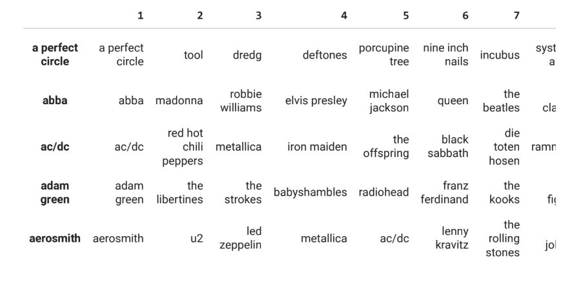User based: